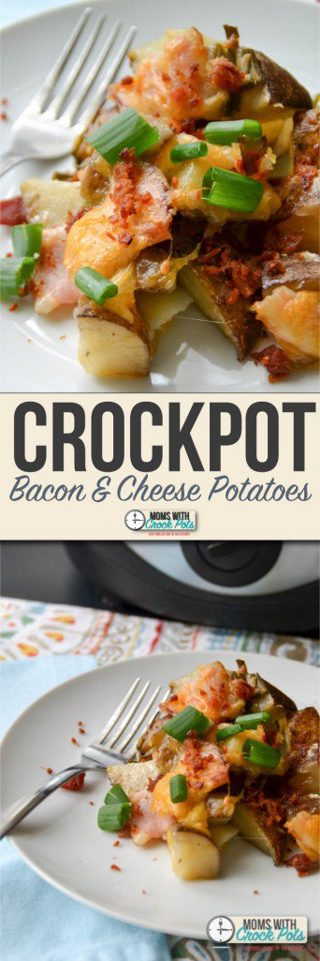
Watermelon Tacos
Growing Green August 2016 Snack Menu
Monday | Tuesday | Wednesday | Thursday | Friday
1  AM: Cereal & Milk  PM: Cheese w/ Crackers & Water | 2  AM: Bagels w/ cream cheese & Milk  PM: Veggie Chips &  Milk | 3  AM: Diced Pears & Milk  PM: Graham Crackers & Milk  Milk | 4  AM: Sun Butter on Bread & Milk  PM: Seasonal Fruit | 5  AM: Cereal & Milk  PM: Pretzels & Milk | 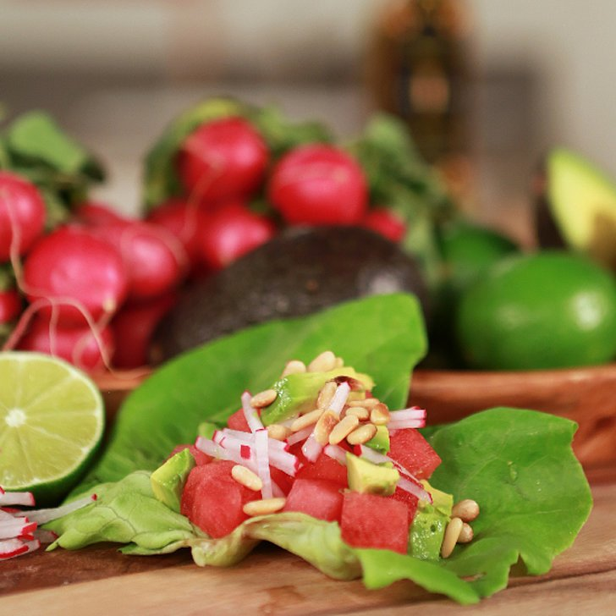
8  AM: Cereal & Milk  PM; Salsa w/ Chips & Milk | 9  AM: Peaches & Milk  PM: Bagel Pizzas & Milk | 10  AM: Biscuits w/ Jelly & Milk  PM: Animal Crackers w/ Milk | 11  AM: Cinnamon Toast & Milk  PM: Seasonal Fruit | 12  AM: Applesauce & Milk  PM: Yogurt w/ Granola & Water | 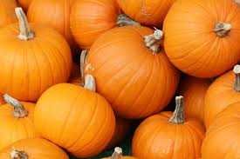
15  AM: Cereal & Milk  PM: Pita Chips & Milk | 16  AM: Yeast Rolls & Milk  PM: Trail Mix & Milk | 17  AM: Pineapple & Milk  PM: Veggies w/ Ranch Dip & Milk | 18  AM: Toast w/ Butter & Milk  PM: Seasonal Fruit  & Milk | 19  AM: Bagels w/ cream cheese & Milk  Ingredients:  4 cups butter lettuce leaves/2 cups seedless watermelon, cubed/1 avocado, cubed/2-3 radishes, julienned/ Extra-virgin olive oil/Juice of 1 lime/Generous pinch of sea salt  Directions:  Fill each lettuce cup with watermelon, avocado, and radishes. Drizzle with olive oil, add a spritz of lime juice, and season to taste with salt. Serve immediately.  PM: Fruit Juice Pops & Crackers
22  AM: Cereal & Milk  PM: Veggie Straws & Milk | 23  AM: Applesauce & Milk  PM: Baked Cheese Crackers & Milk | 24  AM: Animal Crackers & Milk  PM: Pretzels & Milk | 25  AM: Toast w/ Jelly & Milk  PM: Seasonal Fruit & Milk | 26  AM: Yogurt & Juice  PM: String Cheese w/ crackers & Water
29  AM: Cereal & Milk  PM: Goldfish & Milk | 30  AM: Tropical Fruit & Milk  PM: Trail Mix & Milk | 31  AM: Bagels w/ cream cheese & Milk  PM: Salsa & Chips w/ Milk | 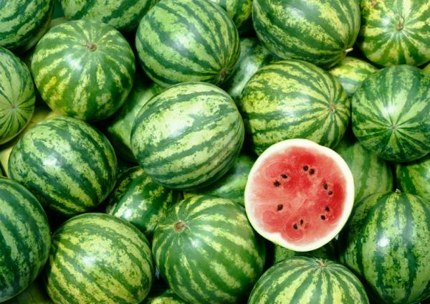

Calendar by www.calendarlabs.com

