MONDAY | TUESDAY | WEDNESDAY | THURSDAY | FRIDAY
12/5 | 12/6 | 12/7 | 12/8 | 12/9
Fiesta Chicken  Steamed Rice  Peas  Pineapple Chunks  Wheat Bread | Meatballs in Beef Gravy  NEW! Parmesan Seasoned Potatoes  Green Beans  Fresh Orange  Italian Bread | Shells & Cheese  Broccoli  Fresh Pear  Rye Bread | Chicken Chili  Rotini Pasta  3 way Vegetable Blend  Tropical Fruit  Wheat Dinner Roll | Hamburger Au Jus  Ketchup  Steamed Rice  Diced Carrots  Fresh Apple  Mini Wheat Hamburger Bun
12/12 | 12/13 | 12/14 | 12/15 | 12/16
Chicken Chili  Rotini Pasta  3 Way Vegetable Blend  Tropical Fruit  Wheat Dinner Roll | Beef Taco  Shredded Lettuce  Shredded Cheddar Cheese  Diced Carrots  Fresh Apple  Soft Flour Tortilla | Pizza Noodle Bake  Green Beans  Diced Pears  Wheat Bread | Chicken and Rice Bake  Winter Blend  Banana  Rye Bread | Chicken Patty Sandwich  BBQ Dip  QC Vegetable Blend  Fresh Orange  Mini Wheat Hamburger Bun
12/19 | 12/20 | 12/21 | 12/22 | 12/23
Turkey Hot Dog  Ketchup  Peas and Carrots  Pineapple Chunks  Hot Dog Bun | Macaroni and Cheese  Broccoli  Banana  Wheat Bread | Turkey Sub Sandwich  Mustard  Shredded Lettuce  American Cheese  QC Vegetable Blend  Tropical Fruit  Italian Sub Bread | Sloppy Joe  Diced Parsley Potatoes  Corn  Fresh Pear  Mini Wheat Hamburger  Bun | Spaghetti and Meatballs in Marinara Sauce  Winter Blend  Fresh Orange  Wheat Dinner Roll
12/26 | 12/27 | 12/28 | 12/29 | 12/30
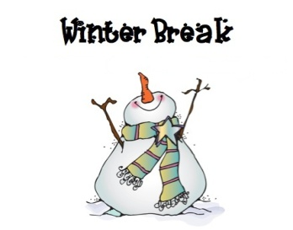 | Chicken Taco  Shredded Lettuce  Shredded Cheddar Cheese  Peas & Carrots  Fresh Apple  Soft Flour Tortilla | Rotini Pasta & Meat Sauce  Broccoli  Pineapple Chunks  Wheat Bread | Pancakes with Turkey Sausage  Syrup  Diced Parsley Potatoes  Banana | Chicken Teriyaki  Steamed Rice  3 Way Vegetable Blend  Tropical Fruit  Wheat Dinner Roll

